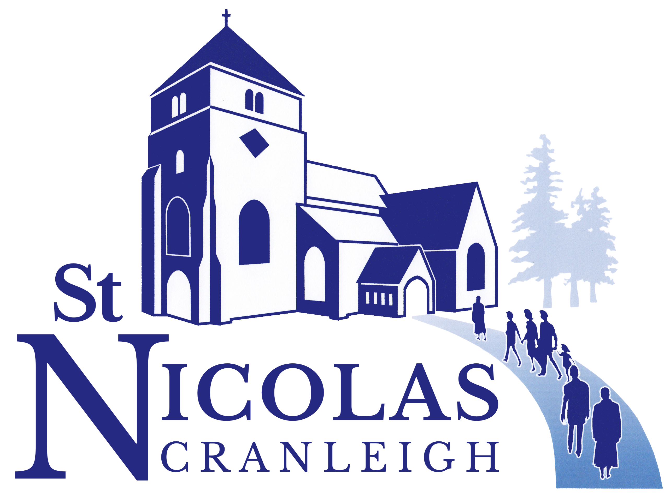

Minutes of a meeting of the Parochial Church Council
Held in the Church Rooms on Wed 10th September at 7.30 p.m.

Present: Roy Woodhams (Chair), Susan Clarke, Alistair Smith, Richard Tuck, Sandra Keeping, Steff Shepherd, James Lester, Sarah Smith, Sue Knight, Nicola Craven-Smith, Erik Heemskerk. Katherine Tuck joined the meeting for items 1-4 on the agenda.

1 Roy welcomed everyone to the meeting and led the opening prayer.

2 Apologies: Paul Jenkins, Alison Hendy, Joan Connolly, Bryn Jones, Claire Jones, Sue Tresman, Margie Nursey and Jane Etherington.

3 The Minutes of the meeting 9th July 2025 were agreed and signed (proposed by Susan Clarke, seconded by Alan Walton).

Matters Arising: None

4 Safeguarding: Katherine Tuck joined us and was voted into the role as Parish Safeguarding Officer (PSO) (All in favour)
We are in top 1/3 of parishes in the diocese for safeguarding, and our dashboard progress is good. Some areas to be actioned:
- List of all church activities was approved, with one addition which was the Ladies’ Evening Group - proposed by James Lester, seconded by Sue Knight. All in favour.
  - Alan raised the question of visiting bellringers needing their own safeguarding policy and risk assessment which Katherine confirmed they would. Nicola and Graham (tower captain) to action this for all bookings going forward
- Approved our St Nicolas procedure for dealing with allegations/concerns. This document outlines all steps to be taken, and copies were given to all PCC members to keep for reference. Proposed by Sandra Keeping, Seconded by Erik Heemskerk.
- All groups are to have attendance register to safeguard both attendees and volunteers. These are all now being implemented.
- Safer Recruitment and People Management. This is something we have not yet implemented and must be done. Katherine has been working with St John’s Merrow to use their already successful model and adapt it to use here.
- Policy and Procedure from Brian’s November report - PCC confirmed they will comply with ‘Lone Working Practice’ and ‘Appropriate Boundaries Practice’. Proposed by Alan Walton, Seconded by Sue Knight. All in favour.
- Diocesan Campaign: See it, Hear it, Report it. Making everyone aware that they have a responsibility toward safeguarding in our church.
  - Plan to make Safeguarding Sunday 16th November a visible recognition of safeguarding in the services.
  - Erik, Katherine and Claire Jones will be planning content for service
  - Pre-service slides to show information
  - Open invite to all members of congregation to do basic online training.
- Introduction of new Safeguarding Hub, attached to our current dashboard, from 15th September. This is a range of tools to help implement safeguarding more easily, and allow the Diocese to see our data and offer support, advice and auditing. PCC needs to approve a hub owner (suggested this be Katherine). Proposed by Sandra Keeping, seconded by Susan Clarke. All in favour.
  - New incumbent to be added as user once installed.
  - PCC delegates powers to the standing committee if any safeguarding issues need addressing between PCC meetings. Proposed Katherine Tuck, seconded by Maurice Bowles. All in favour.

Other safeguarding questions raised:
- Alan – recent DBS data breach. Bishop has spoken about it encouraging people to be alert. Diocesan has it in hand. Seven of our DBS applicants have had data taken, no money involved. There is a hold on DBS checks being processed until situation is fully rectified.
- Who’s Who Safeguarding poster has been updated
- Maurice asked about lone working policy for church volunteers. Susan confirmed we have one in place and it is shared with volunteer groups annually. Richard added that technology can also help with this as newer phones/smart watches can alert ICE (In Case of Emergency) contacts in the case of a fall etc.
- Susan shared that we plan to thank Brian for his incredible work on Safeguarding at the service on 12th October.

Roy thanked Katherine for joining us and for taking on the role of PSO. Katherine then left the meeting.

4i Bullying and Harassment Complaints Procedure PCC agreed to adopt. Proposed Alan Walton, seconded by Richard Tuck. All in favour.

5 Treasurer / Finance Team

Alistair had circulated his report (see attached document) prior the meeting and no questions were raised.

PCC voted to adopt the Delegated Authority for Admin and Petty Cash. Proposed Richard Tuck and seconded by Sue Knight. All in favour.

Data storage – Microsoft have changed pricing structure and going forward this would cost us upwards of £500 per annum for our current applications.
- Option 1 – online only MS Office access – no cost for up to 300 people. Recommended as default for general use
- Option 2 – pay a monthly fee for enhanced data protection, and desktop applications. Recommended as best option for those who have access to banking, personal details etc.
Susan clarified that the proposal means that we pay to use the full version (option 2) for all church laptops (Administrator, Incumbent, Curate) and we choose option 1 for those who access from home computers. Richard confirmed.
- Richard highlighted the paragraph re Multifactor Authentication, using Microsoft Authenticator app on a phone. This gives an extra layer of security. There were concerns about how onerous this would be to use – Sarah Smith said she does this at work and it is straightforward and easy to get used to. Steff Shepherd agreed.
- Susan raised the issue of the church laptop being used by multiple users for AV. Richard is going to investigate possible solutions to that problem.
Richard said PCC need to decide what level of risk they are comfortable with, we can add MF authentication person by person.
Proposal that we accept the MS Office access plan outlined above, and MF authentication. Proposed by Richard Tuck, seconded by Maurice Bowles. All in favour with 2 abstentions.

Insurance update – current policy doesn’t cover 3rd party events held in church e.g. Queen Six/Heritage Day. We need to check organiser has their own liability insurance at an appropriate level, and share their risk assessment with us. Roy suggested that next year we look into using Ecclesiastical Insurance as he thought they might offer more comprehensive cover.

6 Young People and Families

Steff – Ignite has a new notice board in St Andrews Room which will be updated regularly. Meeting Sundays 5-6pm starting this Sunday. We are still considering a possible younger Ignite to accommodate the younger siblings.
Made links with CBC Youth Leader, John, for combine activity. Will ask for PCC permission when details are confirmed.
Open the Book was back for the new term yesterday.
Little Nics is starting at the new time of 9.30am to make it easier for parents to come straight from school drop off.

7 Team Reports:
Outreach and Mission – Alan Walton, as per circulated report, no comments.

Implementation Group – Susan Clarke. The implementation group provided a report to PCC, which in summary said:
- Trackers will now meet in the St Andrew’s Room, following a set of pre-planned topics rather than the lectionary. On the 2nd and 4th Sundays, it will go on a bit longer, to the start of Communion.
- Music will also try to cover a wider spectrum at all 10 am services, with an occasional ‘hymn practice’ before the service to introduce less-familiar songs or hymns.
- Readers and intercessors will come from a broad spectrum of volunteers and we want to mix up the people doing this at all 10 am services so there is representation across the board.
- In a further important attempt to be more inclusive, we will try to involve the Rikkyo School more when they come, try to ensure that disability does not preclude anyone from taking a full part in services, and welcome families with children more effectively (happy bags, welcome packs, directions etc.)
- The Implementation Group will be having one more meeting, but this will be by nature of a follow-up to check on progress and monitor any feedback. No further decisions/ changes will be decided at that meeting that aren’t already in the scope of our recommendations.

Maurice asked if there is a review period of the new service plans. Roy said we cannot make any changes once we are in vacancy, so the review will occur when the new incumbent is in place.
Sue K raised that additional training for those new to doing intercessions would be helpful, and the increase in children reading has been really positive. Steff added that Susan did an excellent job of chairing these meetings.

Proposal by Susan Clarke that we welcome and approve the report from the Implementation Group.
Seconded by Sue Knight. All in favour.

Social Team – Susan Clarke highlighted upcoming events – harvest lunch, Rector Entertains and Roy’s Farewell lunch.
Sandra asked clergy, when advertising Harvest lunch in services, to emphasize “no charge but please do make donations if you are able”.

Rectory Fete – as per circulated report. No comments

8 Church Rooms Nicola advised that kitchen refurbishment is planned to begin 20th October, duration of 3-4 weeks. Thomsons builders have been instructed.
Richard Tuck has agreed to project manage the process, unless anyone from Buildings or Church Halls Management team wishes to do so.

9 Church Building Project Steff has been working very hard on Statement of Needs which is an extensive document. Alan thanked Brian Bagot for his contributions on the history of the church.
Another £2k is needed for 3D images of plans to present to the wider public. Richard Tuck and Alistair confirmed this money was included in last allocation, so it can go ahead.
Re Screening of Baynards – Adam Heike says we should consider including Baynards in the full proposal. If we don’t it will cost us more in the long run to do it as a separate project. Richard felt it was the right decision to include it now.

10 Churchwardens’ Reports:

Susan:
PCC Teams
Up to date list of all PCC teams and who is on them (in particular who from the PCC is on them) is now compiled. Thank you to everyone who gives their time and energy to these teams.
Finalised list to be circulated to the PCC with minutes of the meeting

Car Park
Monies - June £707 July £832 so income remains steady
Vandalism to camera and pole has been reported to ECP and they are to action.
Tarmac to the walkway area was done and has provided a clear access point for people to get to the church halls. Thank you Richard.
New disabled bays etc have been painted, as a result of our safety assessment of the car park. – one negative feedback about the siting near the entrance, which was reviewed and responded to.

Vacancy As part of the vacancy process we have to elect a Management Team to meet at the beginning of each month and ensure that things are running smoothly – to quote from the vacancy pack, “to ensure that the diary is up to date; that communication between members of staff is maintained; that work previously done by the incumbent is managed and shared; that problems are addressed and the area dean is kept in the loop and consulted if necessary… It is suggested that a churchwarden chairs this group.”

The PCC was asked to approve the following:

“The PCC approves the setting up of a Management Team to meet regularly during the vacancy to ensure the smooth running of the parish. Members will be:
Churchwardens (Susan Clarke and Alan Walton)
Clergy (Erik Heemskerk, Sue Tresman + hon clergy to be invited)
Parish Administrator (Nicola Craven-Smith)
Treasurer (Alistair Smith)
Director of Music (Michael Clarke)
Youth Leaders (Steff Shepherd and Claire Jones)
+ Area dean - to be invited

The team will aim to meet monthly (probably on the First Wednesday evening of each month from 7.30pm) and will be chaired by churchwarden Alan Walton.”

Maurice wondered if the group was too big. Susan answered that not all on the list will attend but are welcome to. They can submit updates to group by proxy.
Proposed by Susan Clarke, Seconded by Sue Knight. All in favour.

Alan:
- PAT testing has been done for this year. Plea to ask that any portable electrical items that are no longer used to be reported to churchwardens to be taken out of circulation, as any items over 100 are chargeable.
- Cedar Tree – canopy to be reduced. Re-categorised as ‘Atlas Cedar’, not ‘Cedar of Lebanon’. After reduction work it will be re-assessed to see if permanent fence or other measures are needed. If iron banding is required the cost will be incredibly high.
Richard suggested that a public campaign to support the costs of saving the tree could be successful as members of the public are invested in the fate of the tree!
- Quinquennial inspection went well. Awaiting written report from architect.
- Uneven surface signs in place for the path in churchyard. Steff suggested refurbishment of the path should be included in the Vision 2030 accessibility plans.

11 Eco Church: Roy reported that Sue Tresman will want to step down as the lead on this now that she is being ordained. We will need someone to step into this role.

12 1170 Sue Knight thanked everyone for their efforts in delivering the heritage day leaflets.

13 Rector’s Business:
- Sue Tresman’s ordination is on 28th September. Please keep her in your prayers. Harvest lunch on 5th October will be a joint celebration of her ordination.
- Rodney is in hospital having had a suspected heart attack, requiring bypass surgery. Keep in prayers
- Chris Robinson’s funeral is on 8th October at 2.15pm. He was a huge part of this church for many years through is roles as tower captain, in the choir, and more.
- Roy has been appointed Assistant Archdeacon of Surrey. PCC gave their congratulations.
- Nicola’s hours have been adjusted to accommodate family pressures. She will do the same number of hours but across three days (Mon, Wed & Fri) instead of four.

14 Any Other Business: None

15 Date of Next Meeting: 12th November.
The churchwardens have a meeting with Phil Andrews (assisting archdeacon) on 1st October for first vacancy meeting. Following this there will be an Open Meeting with the congregation, date to be advised when known.

The meeting closed with the Grace.

