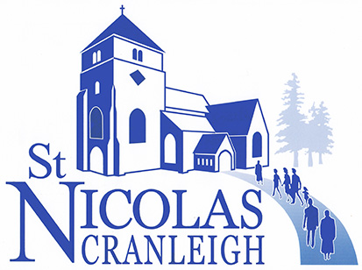

**Minutes of an extra-ordinary meeting of the Parochial Church Council**

**Held in the Church Rooms on Sunday 6th April 2025 at 11.30 a.m.**

**Present:** Roy Woodhams (Chair), Susan Clarke, Alan Walton, Alistair Smith, Paul Jenkins, Maurice Bowles, John Watson, Erik Heemskerk, Bill Rothwell, Joan Connolly, Richard Tuck, Bryn Jones, Sandra Keeping, Alison Hendy, Sue Knight,

**Apologies:** Sue Tresman, Margie Nursey, Steff Shepherd, Nigel Lynn, Nicola Craven-Smith

The purpose of this extra-ordinary meeting was to approve the audited accounts for the year to December 2024 prior to the 2025 APCM.

The audited accounts were approved, with all in favour – proposed by Bryn Jones, seconded by Sue Knight and signed by the Chairman, Roy Woodhams.

The meeting closed at 11.33 a.m.